**Assignment 4**

**Objective** – Power BI Desktop, Cloud Service and End to End Workflow

**Use Case** – Working with Date & Delimiter

**Source** – GOT

**Analytics** – The raw data - your task is to transform it into something more presentable.

**Report/Dashboard** – GOT

**Task 1: Split the author column in two and replace the resulting nulls with blanks.**

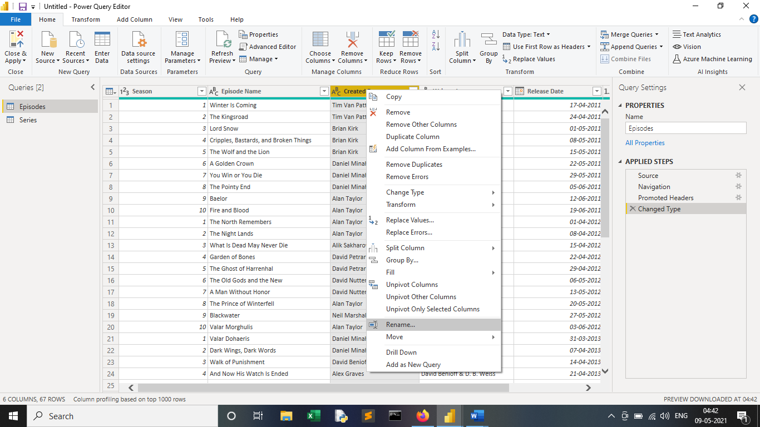

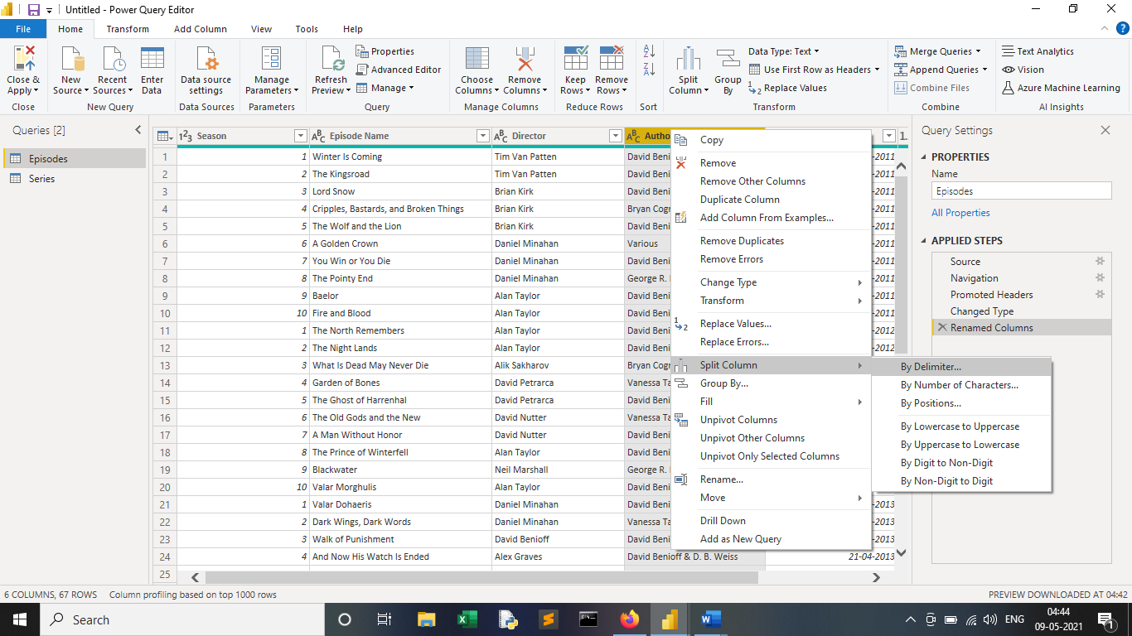

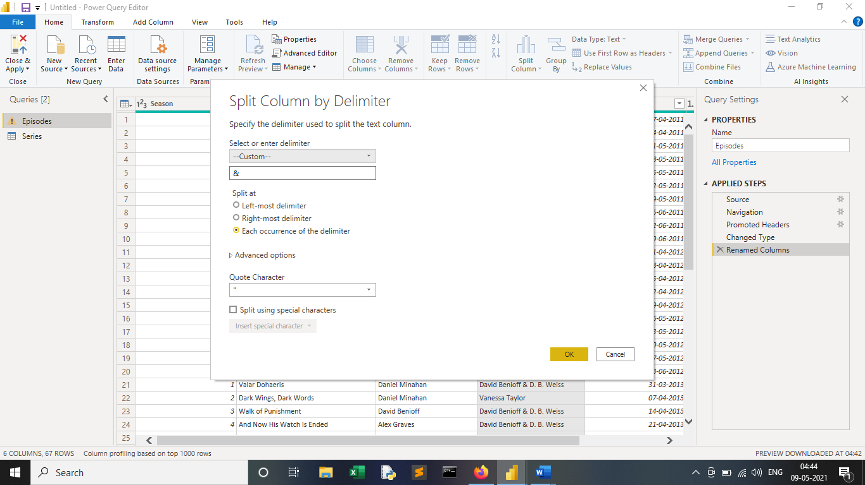

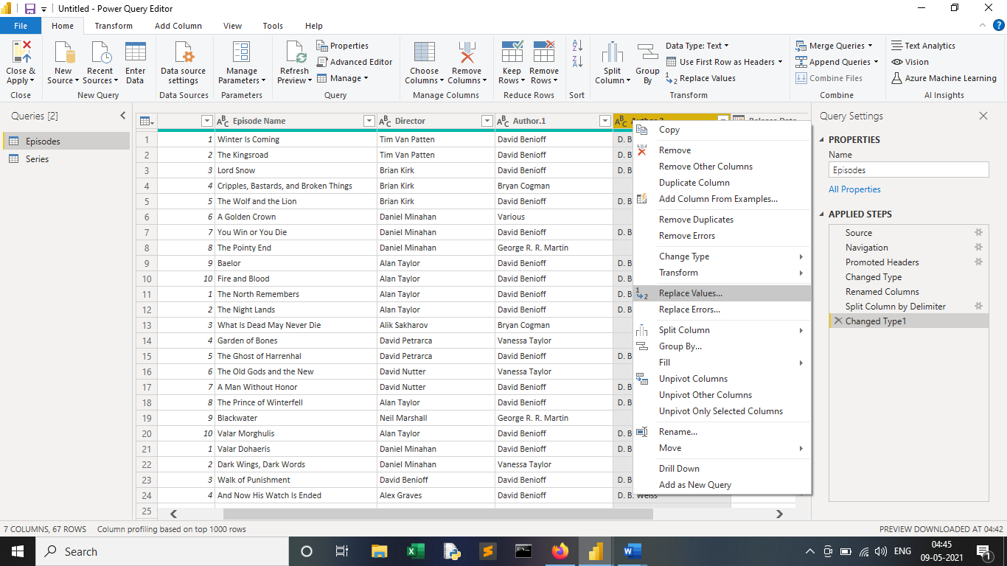

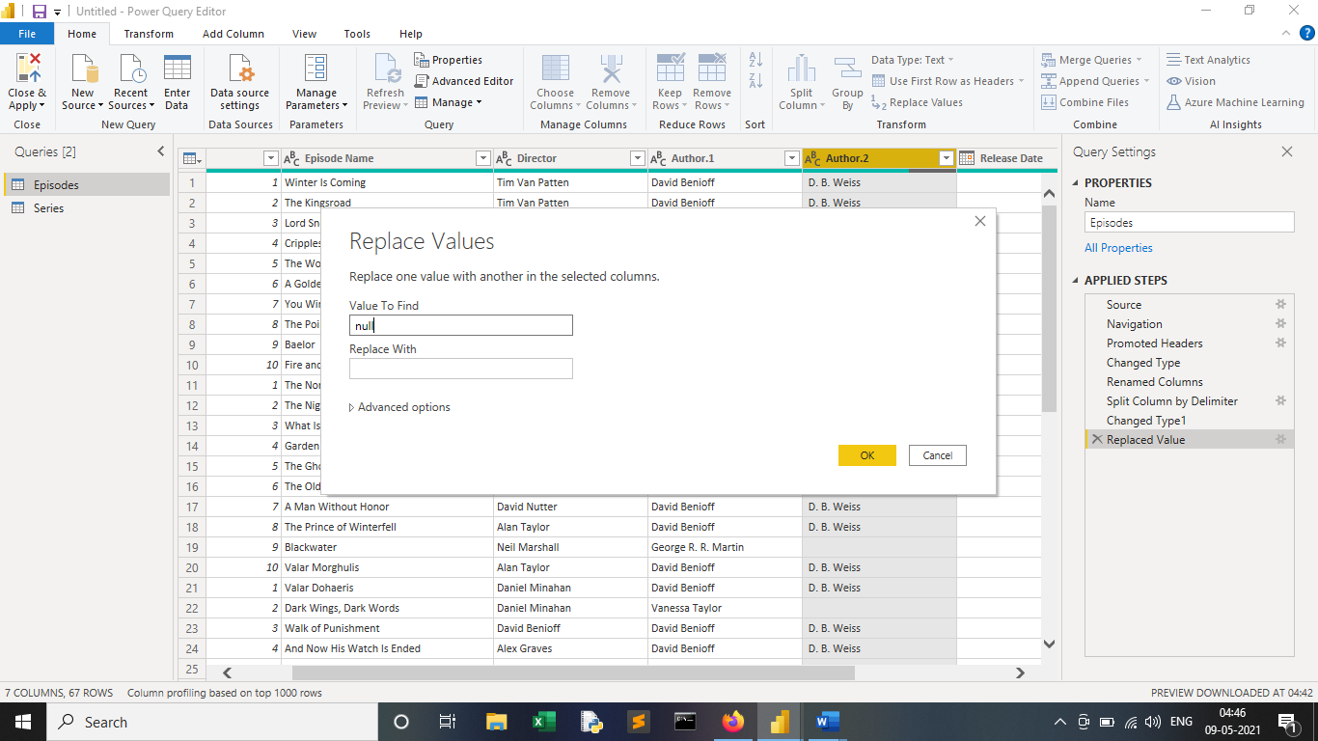

**Task 2:** The dates need to be format as I am not happy, they are appearing.

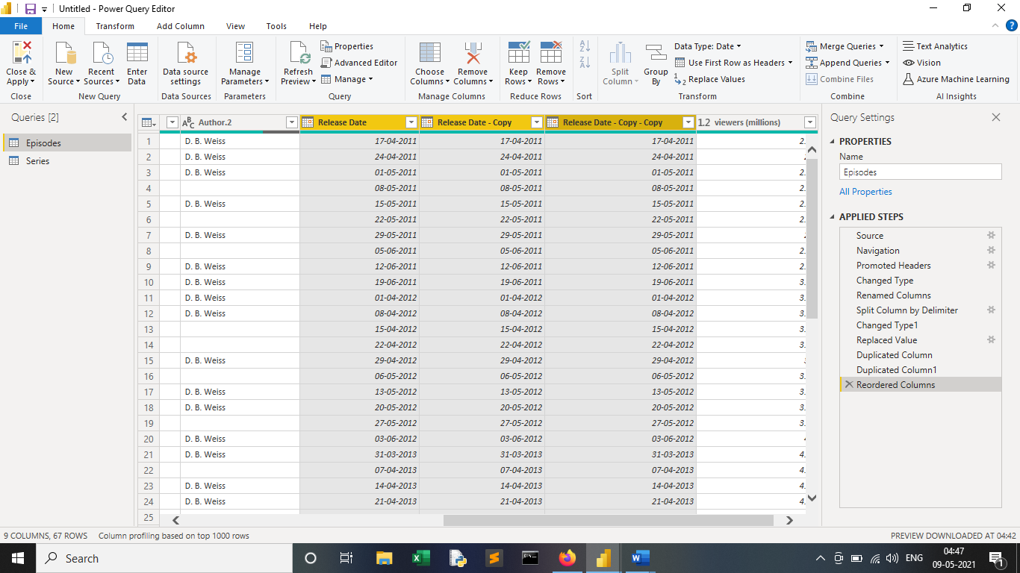

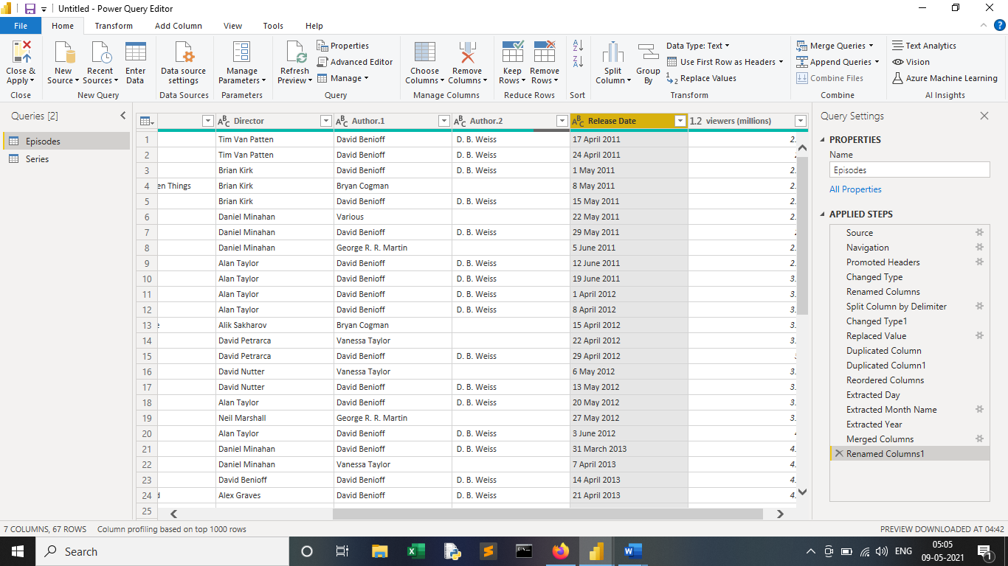

**Task 3:** You should also filter the data to show only episodes directed by Daniel.

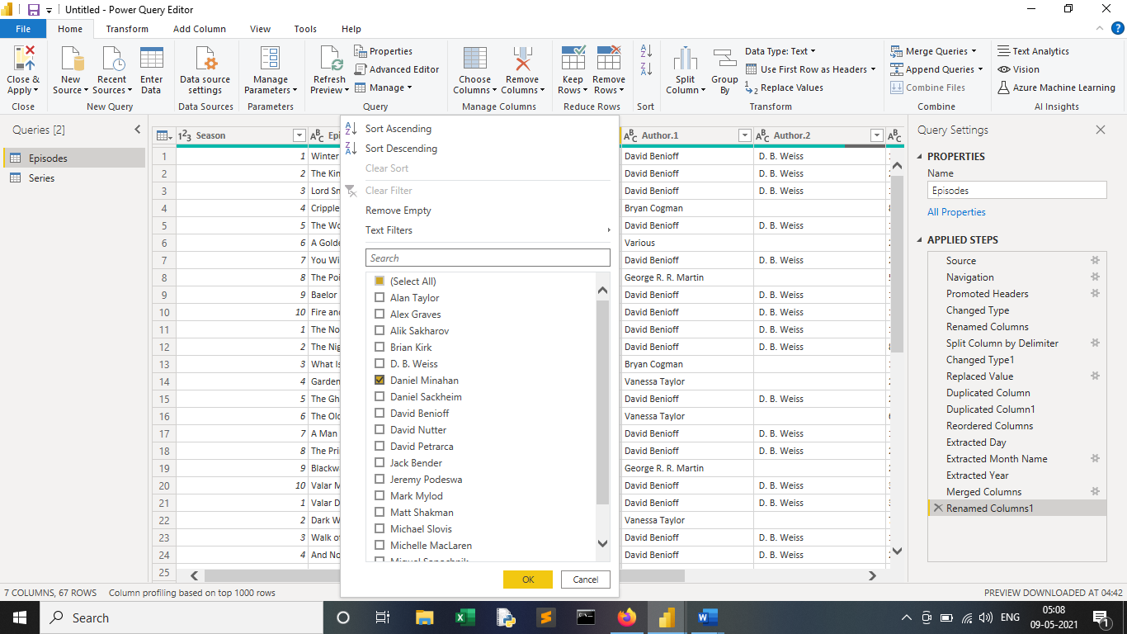

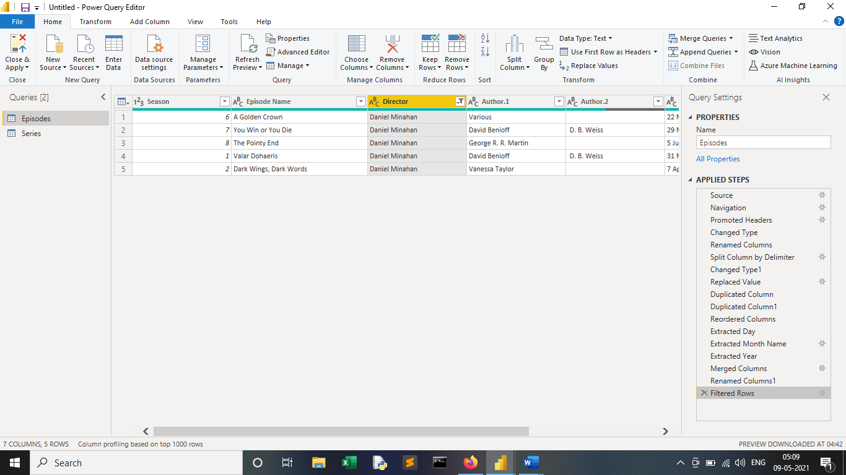

**Task 4: Should show how many people watched each episode Written by the various authors**

**o Episode Name**

**o No. of viewers**

**o Mostly watch Directors**

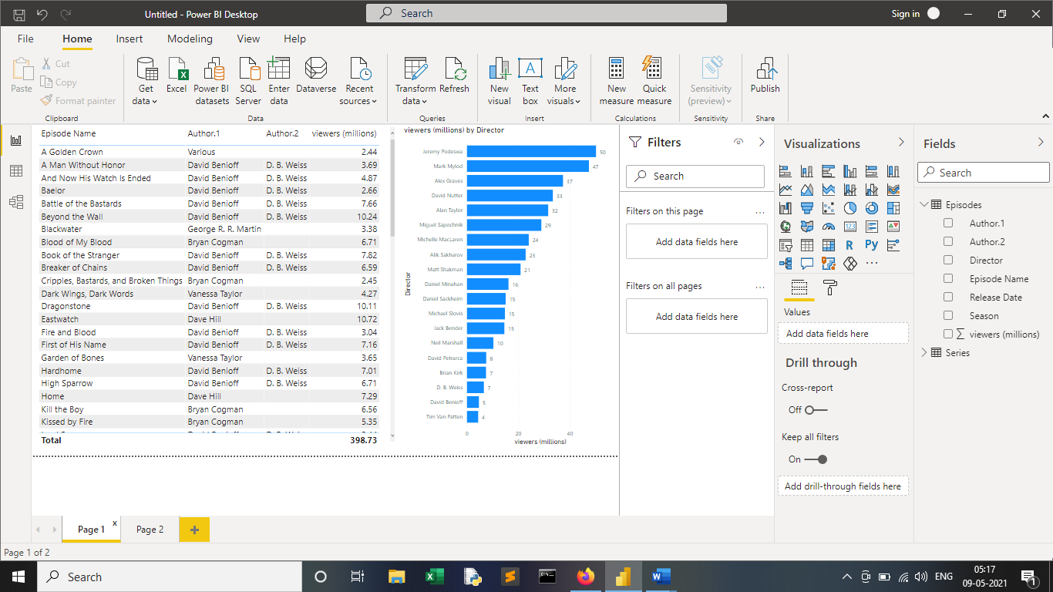

**Task 5: Can you show me some interesting insights in terms of the release dates that will help me to have an idea about frequency of each episode coming up and help me to plan the future production?**

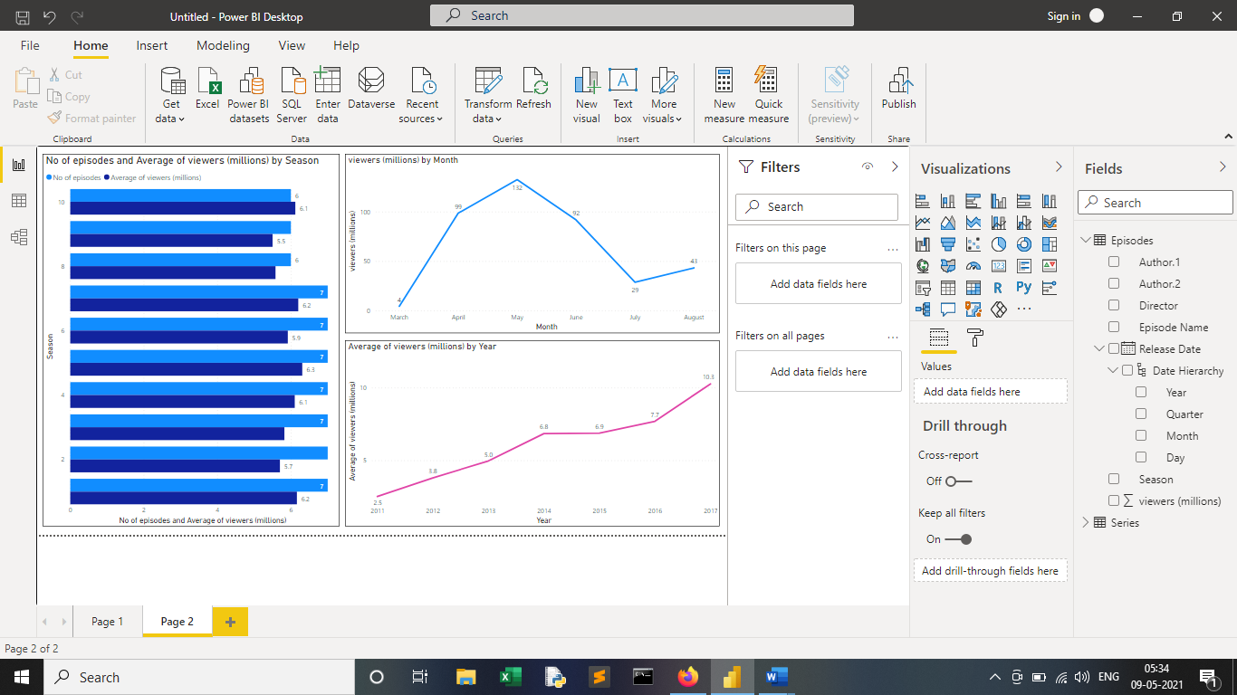

**Conclusion**- Thus in this Assignment we learn to use various function in Power Query Editor like *Add Column, Split column, Formatting Date, Using Merge and Replace column, Filter Data* option which are very crucial features in Power Query.

* From the First Table and chart we can conclude Result that, "The Dragon and Wolf" with Author "Daniel Benioff" and "D.B. Weiss" was the Highest watched Episode in GOT series with Audience views of 12.07 Million Viewers.   And Episode of "The Kingsroad" with Author “Daniel Benioff" and "D.B. Weiss" was the Lowest watched Episode in GOT series with Audience views of 2.20 Million Viewers.
* In the Clustered Bar Chart, we have visualization of Mostly watch Director, here "Jeremy Podeswa" was the Most watched Director in GOT series with 50.21 Million Viewers and “Tim Van Patten" was the Lowest watched Director in GOT series with 4.42 Million Viewers.
* From the Second Visualization we get Interesting insights like, As the Season Progresses in GOT, No of Episodes have been Reduced from count of 10 Episodes to Total 7 Episodes in Season 7 & Total 6 Episodes in Season 8, which is beneficial as the No of Viewers has Increased by reducing the Episodes, so it will be ideal to keep Episode’s minimum to *5-7* in upcoming *Season 9*, so there will be more no of Viewers for upcoming GOT season.
* Analysing second Line Chart we come to know that GOT series have been always Launched their Episodes between March to August. From this Most of the Viewers were in the Month of March with 132.37 Million Viewers, and Lowest Viewers were in the Month of July with 28.63 Million Viewers. So, it will ideal to stream most of the GOT season Episodes in March Month and to avoid July & August Month, as it has the Lowest No of Viewers Count in GOT series.
* And from the Third Line Chart we come to know that No of Viewers have been Increasing Every GOT Season, so it will safe to Assume that Next Season will have even more Viewers than the Previous season.  Here Season 1 had the Lowest Viewers count with 2.52 Million Viewers, whereas Season 7 has the Highest Viewers count of 10.26 Million Viewers, so the Viewers Count have been Increased 4 times approximately from Season 1 to Season 7.